**Student Name: Basavraj Nagappa Jaliminche**

**Student Id: 8800149**

**PROGRAM: Reporting Systems and Database Development (1517)**

**Course Name: Relational Databases PROG 8590**

**Assignment No: 05**

**Assignment 5**

**Question 1 – Working with Variables and Displaying Output [5 Marks]: Write PL/SQL to do some basic variable manipulation. Store in variable 1 the string "Hello" and store in variable 2 the string "World". Print the concatenated variable 1 to variable 2.**

**Answer:**

DECLARE -- declaring section

v_string1 varchar2(5):='Hello'; -- Declaring variable with value as given

v_string2 varchar2(5):= 'World'; -- Declaring variable with value as given

BEGIN --execution section

DBMS_OUTPUT.put_line(v_string1||' '||v_string2); --Concatenating two variables

EXCEPTION --exception handling section

WHEN OTHERS THEN

DBMS_OUTPUT.put_line(SQLERRM);-- Displaying the SQL error messages

END;

In the anonymous block We have stored one value in the the string1 as “Hello” and other value in string 2 as “world”

After that we have done concatenation for the two strings to get output as “Hello World” with exception handling.

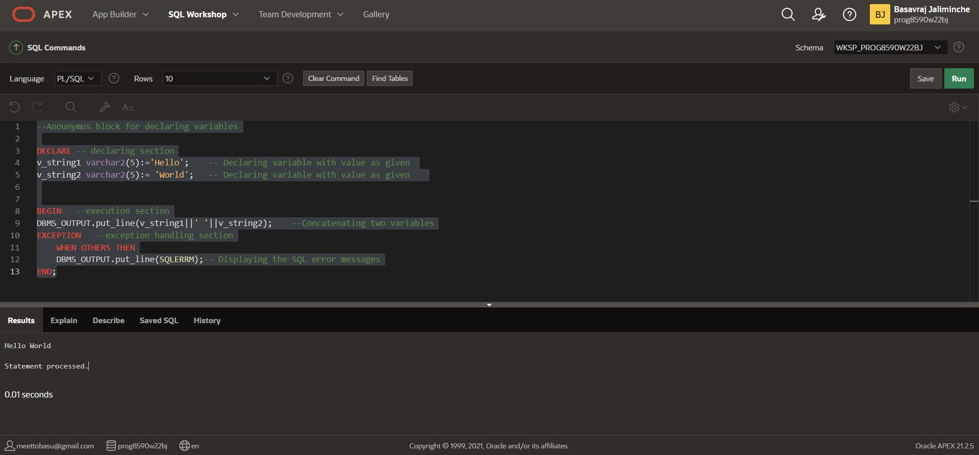

**Question 2 – Conditions and Exceptions [10 Marks]: Write a PL/SQL program to determine the lowest of three numbers by using Nested-If statement. The numbers will be assigned in the declare section.**

**Answer:**

DECLARE -- declaring section

N_number1 number:=14; -- declaring variable with value for first number

N_number2 number:=9; -- declaring variable with value for second numer

N_number3 number:=11; -- declaring variable with value for third number

BEGIN --execution section

IF(N_number1 <= N_number2 AND N_number1 <= N_number3) THEN --IF condition for checking smallest number between the three numbers

DBMS_OUTPUT.put_line('Out of Number1: '|| N_number1 ||', Number2: '|| N_number2||', Number3: '|| N_number3||'. '|| N_number1|| ' is the smallest number between.');

ELSIF(N_number2 <= N_number1 AND N_number2 <= N_number3) THEN --ELSE-IF condition

DBMS_OUTPUT.put_line('Out of Number1: '|| N_number1 ||', Number2: '|| N_number2||', Number3: '|| N_number3||'. '|| N_number2|| ' is the smallest number between.');

ELSE ----ELSE condition will execute if all other condition fails

DBMS_OUTPUT.put_line('Out of Number1: '|| N_number1 ||', Number2: '|| N_number2||', Number3: '|| N_number3||'. '|| N_number3|| ' is the smallest numberbetween.');

END IF; --end of if block

EXCEPTION --exception handling section

WHEN OTHERS THEN

DBMS_OUTPUT.put_line(SQLERRM);-- Display the SQL error message

END;

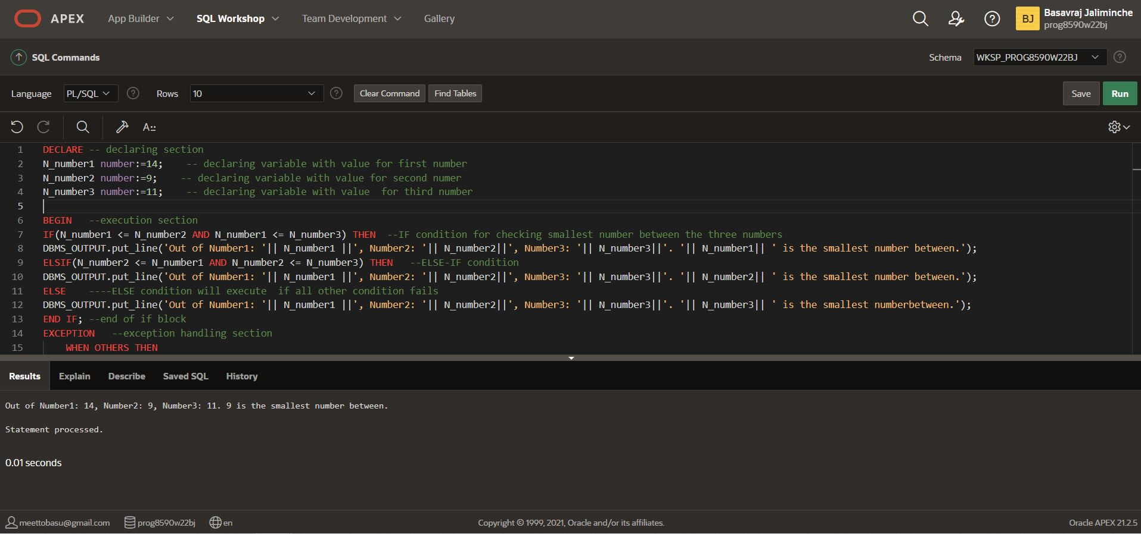

**Question 3 – Cursors [20 Marks]: Write a PL/SQL program to output ID, first name and last name and salary from OEHR_EMPLOYEES. To do this, use explicit cursor. Expected result: 100 Steven King 24000 101 Neena Kochhar 17000 102 Lex De Haan 17000**

**Answer:**

DECLARE CURSOR c_employee_salary IS --Define cursor with Name

SELECT EMPLOYEE_ID, FIRST_NAME, LAST_NAME, SALARY FROM OEHR_EMPLOYEES; --query for cursor defined

vid OEHR_EMPLOYEES.EMPLOYEE_ID%TYPE; -- Define variable which can hold data returned from cursor declared

vfname OEHR_EMPLOYEES.FIRST_NAME%TYPE; -- Define variable which can hold data returned from cursor declared

vlname OEHR_EMPLOYEES.LAST_NAME%TYPE; -- Define variable which can hold data returned from cursor declared

vsalary OEHR_EMPLOYEES.SALARY%TYPE; -- Define variable which can hold data returned from cursor declared

BEGIN

OPEN c_employee_salary;

LOOP --start loop

FETCH c_employee_salary INTO vid,vfname,vlname,vsalary; --store values into variables

EXIT WHEN c_employee_salary%NOTFOUND; -- halt loop statement if not found

DBMS_OUTPUT.put_line(vid||' '||vfname||' '||vlname||' '||vsalary); --displaying output

END LOOP; --end loop

CLOSE c_employee_salary; --closing cursor

END; --end cursar

